

Delivering Change

Project Management Handbook

Version : 1.0
Dated : 16th July 09
Table of contents

Introduction 1
What is a project? 1
Principles of good project Management 1
Scapa Project Phases 2
1. Phase 1: Concept & Evaluation 3
1.1 The Project Mandate 3
1.2 Stakeholder Engagement 3
1.3 The Project Brief 4
1.4 Assurance Planning 4
1.5 Risk Identification and Management 4
1.6 Preparation of Initial Business Case 5
1.7 Concept Approval 5
2. Phase 2: Initiation and Planning 6
2.1 The Project Definition Workshop 6
2.2 The Project Initiation Document 6
2.3 Establishing Project Governance and Control 7
2.3.1 Project Management Structures 7
2.3.2 Key Roles and Responsibilities 9
2.3.4 The Project Issues Log 10
2.3.5 The Lessons Learned Log 11
2.3.6 Financial Tracking 11
2.3.7 Project Administration 12
2.4 Detailed Project Planning 13
2.5 Completion of the Phase 14
3. Phase 3: Delivery 15
3.1 Controlling the Delivery Phase 15
3.2 Status Reporting, Review and Challenge 15
3.3 Managing Workstream Interdependencies 16
3.4 Change Control 17
3.5 Replanning 17
3.6 Completion of the Phase 17
4. Closure & Post Review 18
5.1 Post Project Lessons Learned Review 18
5.2 Document Archiving and Lockdown 18
Jargon Buster 19

Introduction
This document describes the overall process for the management of Scapa projects. The contents are endorsed by the Group Board. This document and the defined standards are mandated and owned by the Group Finance Director, who has Group responsibility for Change Risk within Scapa.
It defines the processes and procedures which must be followed throughout the project lifecycle for complex and material change projects.
Material projects meet the following criteria:
- Project Costs are anticipated to be £0.5m, and/or
- The project is expected to run for more than six months.
For smaller and less complex and less material projects the handbook is available as a source of guidance, however, the principles defined must be applied across all Scapa projects.
A number of support document templates are also available within the Project Management Document Library accessible via the Intranet.
It should be used by Project Steering Committees, Project Accountable Executives, Project Managers and project staff.
The handbook standardises the basic process for project management thereby achieving consistency of approach and best practise across all areas of Scapa. This should help increase the likelihood of individual projects delivering the envisaged benefits and objectives, within agree timeframes to agreed budgets.
The processes advocated in this handbook align to Prince 2, the international standard for the management of business change. It should also be read in conjunction with Scapa’s IT Change Management processes and procedures, which cover for example strategies and procedures around IT system development and testing.
It also aims to provide new Project Managers with guidance and direction in terms of project management methods, complementing structured training events.
The document does not cover the processes associated with Programme Management, which are typically represented by a series of projects. Programme Management is subject to separate guidance.

What is a project?
There are many definitions of what constitutes a project, but put simply it is ‘a temporary organisation that is needed to produce a unique and predefined outcome or result, at a pre-specified time, using predetermined resources.’

Principles of good project Management
Project management provides a structured approach to project delivery to achieve the best results. Too often a project fails because of the lack of structured processes throughout the project.
The application of standard and simple processes to project management will enable the following to be achieved on all projects:
- Appropriate delegation of responsibility
- A controlled and organised start, middle and end
- Regular reviews of progress against plan and against the Business Case
- Flexible decision points
- Automatic management control of any deviations from the scope and plan
- The involvement of management and stakeholders at the right time and place during the project
- Good communication channels between the project, project management, and the rest of Scapa
- Early warning and the ability to manage down any project risks and issues
- The ability to end a project prematurely if it becomes no longer worthwhile or viable
- The ability to manage external suppliers against a standard methodology
- The ability to monitor a project through reports, e.g. monthly Red Amber Green (RAG) status reports on progress, cost and risk etc.
- Control processes associated with the deliverable built in during the project e.g. new IT systems which come complete with controls designed and tested.
When using this method to manage a project, the Project Manager will find that a large element of the work is completed during the Initiation and Planning Phase. Scapa’s approach to project management is based on gaining a thorough appreciation of a project before committing substantial resources.

Scapa Project Phases
Projects typically follow several phases which collectively result in a complete project lifecycle. The diagram below articulates the four core phases which Scapa projects observe.

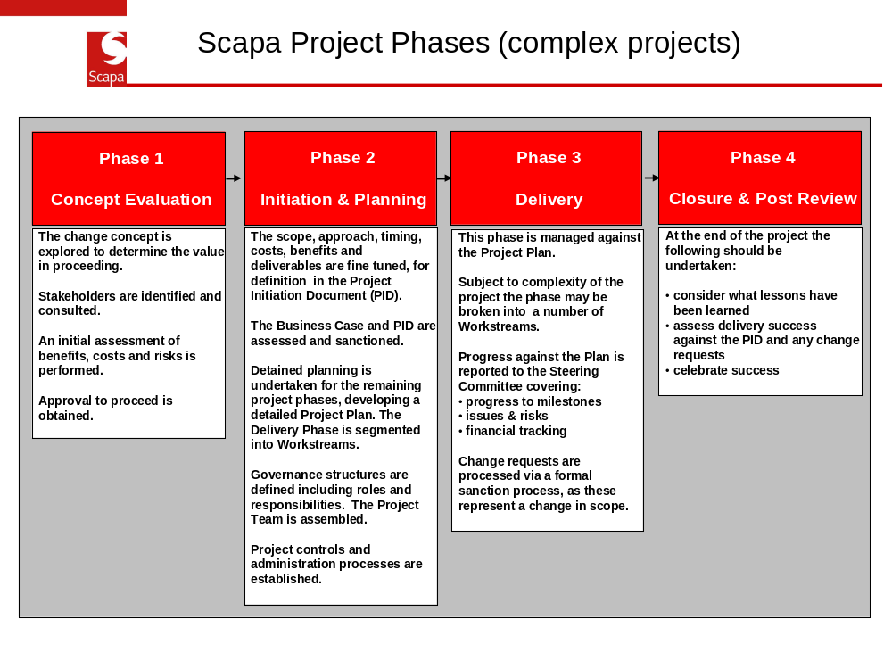

This handbook is structured to align to the above four core phases.

1. Phase 1: Concept & Evaluation
This phase lays the groundwork and foundations for the rest of the project. Setting the basis and framework for the project involves establishing the answers to a basic question:
“Do we have a viable and worthwhile project?”
The following sections cover the tasks and activities completed during this initial phase.
By their nature, projects can be associated with confidential or sensitive information and issues. An example might include where there is a potential impact on employee levels or positions. At the very start of a project such sensitivities must be assessed by the Accountable Executive (AE) - see 2.3.2. Appropriate steps must be put in place to manage the associated issues.

1.1 The Project Mandate
The Project Mandate is a short written description of why the project might be worthwhile and what it intends to achieve and is typically only one or two pages long. This describes the raw concept. The Project Mandate:
- is the first element of the project,
- should identify the project’s AE,
- is usually the catalyst for preparing a full Project Brief (see 1.3), and
- is the initial idea for the project.
A common mistake when completing the Project Mandate is to underestimate the potential costs of delivery for the end product. The AE must ensure allowances have been made for the funding of any additional project staff to resource the team on either a short or long-term basis. From a simple analysis of the cost, it may transpire that the project is not viable.

1.2 Stakeholder Engagement
It is vital to the success of any project that stakeholders are recognised and managed correctly and that they are engaged during this first phase to ensure that their views and knowledge are factored into the scope and nature of the project. They may be individuals, a group, or a subgroup that has an interest in the project. As the project progresses and the focus of the work changes then the stakeholders may also change.
It is important to review current stakeholders at regular intervals throughout the project. A common criticism of many projects is that stakeholders were not kept informed of changes and developments, and that this more often than not has a negative impact on the project.
It may be that not all stakeholders will support the changes brought about by the project. A key part of this analysis is to recognise the stakeholders’ level of commitment to the project and any objections that they may have to the changes brought about by the project.
Examples of some typical stakeholders:
- Users
- Project team member
- Customers
- Employees
- Human resources
- Suppliers and subcontractors
- Trade unions
- Public relations
- Pressure groups
- Legal/Regulators/Local authorities

1.3 The Project Brief
As this phase proceeds the scope and nature of the project should become more clear. The Project Brief is a more refined description than the Project Mandate, setting out what the project will achieve. The Project Brief must have the approval of the AE and where necessary the Group Board.
When a Project Manager compiles the Project Brief, it may highlight some potential risks and the completion of the Project Brief usually corresponds with the start of the Risk and Response Plan (see 1.5). It is unlikely that all associated risks will be recognised by this one process and a formal risk analysis and categorisation workshop should be considered – the Group Risk and Assurance Function can facilitate such a workshop. It is possible that the inherent risks are so great, either through impact or probability that the best option is not to continue. If this is the case, the project AE will have to take the decision to either redefine the scope or to close the project.
A Project Brief should be completed as early as possible in the Project Lifecycle. It can then be used to inform other stakeholders about the aims of the project. This is a more developed version of the Project Mandate and is typically three to four pages long.
A Project Brief template is available in the document library.

1.4 Assurance Planning
The Group Risk and Assurance (GRA) function should be contacted as early as possible in the Project to consider assurance needs, both from the AE’s perspective but also the Audit Committee. GRA will liaise with the AE and Project Manager to determine whether assurance reviews are required and at what stage. These activities are then recorded in the Project Plan.

1.5 Risk Identification and Management
It is vital to the success of any project that the Project Manager recognises and manages associated risks. The Group operates a Risk Management Policy which the Project Manager and AE must observe.
In the context of Projects, risk are those events that have the potential to threaten the successful delivery of the project’s stated objectives.
The Project Manager must maintain a register of risks during the Project, in the form of the Risk and Response Plan. A template is available in the document library.
The Group Risk Policy provides full details, but this template provides a tool to enable the Project Manager to:
- Identify and assess risks.
- Identify record and track Project responses/actions to manage the risks identify, including allocating action owners and due dates.
- Active monitoring by the Project Manager with formal review and reporting to the AE at predefined points of the project.
- For larger more complex projects, an up to date Risk and Response Plan must be used to inform regular meetings of the Steering Committee.
Where risks are identified, management’s responses typically fall into one of the following categories:
Prevention - Where counter-measures are put into place that either stop the threat or problem from occurring, or prevent it from having an adverse impact on the project. For example, stage payments to ensure contract compliance.

Reduction - Where the actions either reduce the likelihood of the risk developing or limit the impact on the project to acceptable levels. For example, training users to operate systems.
Acceptance - Where the AE decides to proceed with the project and accept the possibility that the risk might occur, this decision is always made in the belief that the risk will not occur or that the counter-measures are too expensive.
Contingency - Where actions (or the provision of financial resources) are planned and organised to come into force as and when the risk occurs.
Transference - This is a specialist form of risk reduction where the impact of the risk is passed to a third party. For example, two basic forms of transference would be insuring against the risk or invoking penalty clauses against suppliers.
There is NOT a sixth option of ignoring the risk.
Risks must be recognised and managed throughout the project. Risk recognition is not a one-off ‘tick in the box’ exercise and should form part of the complete management process. A clear understanding of the risks and mitigating actions are vital to the project’s success. An escalation route for identified risks should be communicated to all the project team.
Project Managers and the AE do not have the monopoly on recognising risks, and consultation with service providers and users of the product or service will assist in the process.
The AE or Group Board should not authorise the start of any project until they have satisfied themselves that an initial risk analysis has been carried out and a Risk and Response Plan prepared. Ideally the initial Risk and Response Plan should be used to support the Business Case.
The Risk and Response Plan template in the document library should be tailored to the specifics of the project.

1.6 Preparation of Initial Business Case
The Business Case explains the reason for undertaking the project and the benefits that the project will bring. The Project Manager should outline in the Initial Business Case all benefits justifying the project including financial savings, improvements to current working practices and provision of new services. This should include defining quantifiable benefits and also softer benefits.
The Project Manager should review and if necessary update the Business Case at specific points within the project.
The Business Case should be used to support any formal sanction of the project, either at a Regional or Group Board Executive level.
An Initial Business Case template is available in the document library.

1.7 Concept Approval
Based upon the collective work undertaken during this initial phase of the Project, the Accountable Executive must determine, “Do we have a viable and worthwhile project?”. If the answer is no then work should stop, although the AE may wish to set a review date.
If the answer is yes or possibly, then the project should move to phase 2. This is a formal decision point representing approval to proceed to the next phase of the project.

2. Phase 2: Initiation and Planning
The next phase ensures that the concept explored in Phase 1 is fully assessed and costed, including defining approach, benefits, timings deliverables and risks. The results are documented in the Project Initiation Document (PID) – see 2.2.
Project structures and control processes are also established during this phase. These provide the framework against which future phases will be managed.
Detailed planning is also undertaken, ensuring that personal responsibilities are known within a cohesive project plan, which is capable of being tracked.

2.1 The Project Definition Workshop
Initiation & Planning is a critical phase in the project and mistakes and omissions at this point can cause serious problems further down the line. Indeed, design and definition shortcomings are a prime source of project failure.
Experience has shown the value of holding a Project Definition Workshop (PDW) to underpin this phase.
The PDW is a peer group meeting of stakeholders and relevant managers to help the AE define the project, set objectives, define benefits, and consider resources, costs and risks. The PDW will clarify these aspects and provide a sound basis for the more detailed definition for assembling the Project Initiation Document - see 2.2.
The PDW meeting will be informed by output from phase 1, e.g. Project Brief. Mandate and Initial Business Case, and address the following areas:
- Benefits
- Scope
- Goals and objectives
- Assumptions and risk
- Costs and resources
- Project organisation
- Immediate next actions.

2.2 The Project Initiation Document
The Project Initiation Document (PID) is developed from information/documentation already produced. The completed PID is the basis for authorisation to continue the project. It should be supported by a refined business case.
It provides a basis for all other management decisions that need to be made during the project.
Within the PID, the Project Manager should define a Project Approach. This will define the preferred approach to delivery. By way of example during an Information Technology project it should answer the following questions:
- Will the solution be bought off-the-shelf. In other words, does the solution already exist either as a complete item or in part?
- Will the solution or part of the solution be ‘bespoke’. In other words, will the Project Approach require a development stage to meet the requirements?
- Will Scapa be able to provide a solution, with or without development, without using external suppliers?
- Is the Project Approach based on an existing or recently completed project?
Although the Project Manager is responsible for defining the Project Approach, they may require the input of specialists in certain areas to advise on preferred solutions. Examples of this type of input include IT, HR and legal considerations. Functional experts are available in Scapa and these must be referred to ensure their advice is reflected in the Project Approach, including important specialised aspects of risk.
All projects with an IT element must be referred to the Group IT Manager.
- The PID should define the approach to communications – see below
The PID must be frozen subsequent to authorisation. This is because the PID provides a baseline that can be compared to what is actually delivered at any time during the project but specifically at the Post-project Review. All projects are subject to change throughout the Project Lifecycle. If the project has been managed correctly, all these changes will have gone through review and sanction and can be tracked against the original PID.
A PID template can be found in the document library.

Communications Planning
Depending on the nature of the project a separate Communications Plan should be considered. Effective communications planning will:
- Identify audiences, plan how, when and what to communicate to them.
- Schedule regular updates to ensure stakeholders are kept informed of the progress of the project from start to finish.
- Positively influence perception about the project and ensure buy-in from stakeholders.
- Minimise risks to the project by providing open, effective communication channels that are able to quickly identify and deal with problems that arise.
- Build in evaluation to make sure that key decisions are agreed and to check that communication is working/getting through
Focus and co-ordinate activity by communicating the benefits and aims of the project.

2.3 Establishing Project Governance and Control
This is arguably the most important stage of the project, as it is here that project structures are set and established, ensuring that future phases are managed within a clear framework of accountability.

2.3.1 Project Management Structures
At a basic level any project will have:
- A senior responsible owner, the Accountable Executive
- A Project Manager
- Project support staff, such as a Finance Officer responsible for financial tracking
- Administrative support
- A strategy to ensure Quality Assurance including ensuring the benefits are realised
- Delivery of one or more Workstreams
- Involvement of appropriate staff from the service/s affected by the project.

The following diagram provides an example project structure for a less complex and relatively small project.
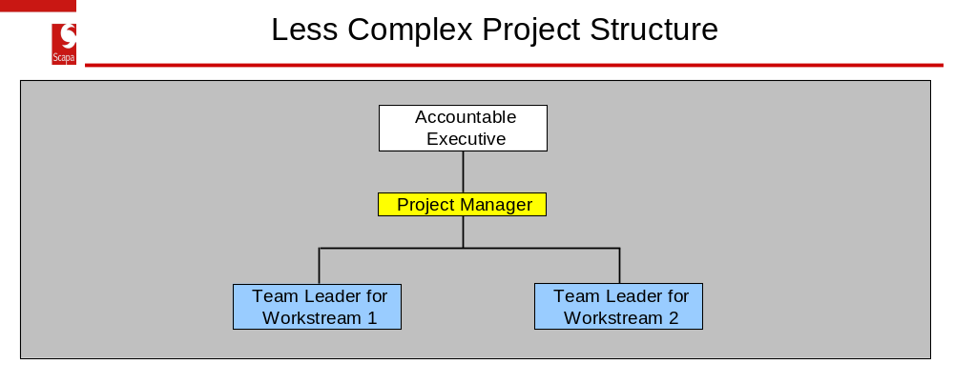
By way of comparison, the following diagram provides an example project structure for a more complex and larger project.
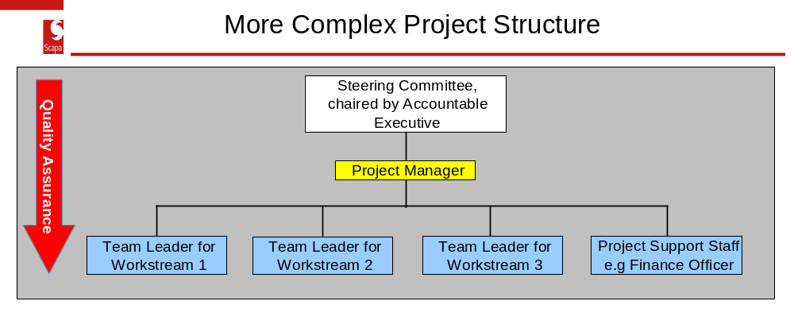
The management team up to and including all Board members must clearly understand their respective roles. All team members have an important part to play in the successful delivery of the project and it is vital that they are kept well informed at all phases.

2.3.2 Key Roles and Responsibilities
Key roles within any project are the Accountable Executive and Project Manager. Their respective responsibilities are described below:
Accountable Executive
The individual responsible for ensuring that a project or programme of change meets its objectives and delivers the projected benefits is known as the Accountable Executive (AE). They should be the owner of the overall business change that is being supported by the project. They should ensure that the project maintains its focus, has clear authority and that the context, including risks, is actively managed. This individual must take personal responsibility for successful delivery of the project. They should be recognised as the owner throughout the organisation. They should remain in place throughout the project or programme.
The AE is the decision-maker responsible for the commitment of resources to the project. The decision to appoint an AE will be determined by the overall budget and complexity of the project. The project may have sufficient materiality and complexity to warrant the appointment for a Group Board member as the AE.
One responsibility of an AE will be to ensure that a project is technically and financially compliant, and is in line with Scapa’s Vision.
The AE must be prepared to take decisions and should be proactive in providing leadership and direction throughout the life of the project or programme.
The AE is responsible for providing approvals and decisions that affect project progress and delivery. For capital projects there is an additional responsibility in relation to corporate approval and financial sign-off via Group Finance Policy. The AE takes executive responsibility for decisions relating to the project and will always chair the project Steering Committee.
The following tasks are the responsibility of the AE:
- Appointment of a Project Manager to organise and control the project and make sure that it meets its objectives.
- Approval of project objectives, scope, Business Case, and the Project Initiation Document prior to any expenditure.
- Communicating information about the project to the organisation and stakeholder groups.
- Responsibility for the authorisation of subsequent budget expenditure agreed by the appropriate forum, in line with the Project Plan, Stage Boundaries, and Financial Forecast.
- Briefing the Group Board on the progress of the project.
- Recommendations and authorisation of future actions on a project, including premature closure or extensions on deadlines or budget .
- To sign off any changes in the Business Case or Budget.
- Chairing scheduled Steering Committee meetings to review and monitor the status of the project against the project plan, including risk and issues management.
- Retaining oversight of the risks owned by the project and highlighted in the Risk and Response Plan.
- Monitoring sign off and approval to move between Phases.
- Approval and sending of the Closure Notice on the project.

Project Manager
The Project Manager retains day to day responsibility for managing all project related activities throughout the duration of the project. They must ensure that they have a suitable project structure below them to discharge related responsibilities. By way of example, on more complex projects a nominated team member will be made accountable for cost and budget management, reporting to the Project Manager.
Key Project Manager tasks include:
- Build and manage the relationship within the Project Team and with internal and external stakeholders.
- Agree how the requirements and objectives will be achieved.
- Prepare and maintain a Project Plan, detailing all activities required to deliver the project to agreed time, cost and quality standards, including allocating ownership of actions.
- Ensure that the distinct project Phases and Worksteams (see 2.4) are identified and planned for.
- Negotiate and agree the delivery of the project with internal support staff.
- Monitor and report with defined frequency to the AE progress against plans, initiate remedial action and resolve problems to ensure delivery.
- Identify and manage risk or general project management issues.
- Manage stakeholder communications.
- Manage the project finances together with support as required from a finance project representative, including preparing expenditure forecasts and actuals as required.
- Escalate issues/problems where appropriate.
The Project Manager should be selected and involved in a project as soon as is possible in the project lifecycle. This ensures that the practical aspects of running a project have been considered when compiling the proposals. Engaging a Project Manager early will ensure a better understanding of the project and provide time for quality planning activity.
In some cases the AE will appoint a Project Manager with little or no prior knowledge of the project. It is essential that a Project Handover Meeting takes place between the AE and the Project Manager to ensure that a full brief is provided, covering the objectives and scope of the project, a copy of any contracts, a copy of the proposal, and a copy of the Business Case containing costs and prices.

2.3.4 The Project Issues Log
During the lifecycle of a project, issues will arise on a variety of project-related matters. The Issue Log is a means of recording these issues and tracking their progress through to conclusion. A unique number must be allocated to each issue. Each issue should be allocated a priority and an owner. There should also be a reference to who raised the issue so that they can be informed of progress towards a resolution. It is advisable to record the type of issue.
It may not be possible to resolve all issues during the lifecycle of the project but the Issue Log provides a vehicle for managing them and assessing their impact. It is not unheard of to have an ongoing issue throughout the complete project.
There are various times in the project Lifecycle when the Issue Log should be reviewed by the AE, such as when moving between phases. The status of issues will be reviewed at each Steering Committee meeting.
A template Issues Tracking Log can be found in the document library.

2.3.5 The Lessons Learned Log
Project Managers should maintain the Lessons Learned Log throughout the project. All lessons learned must be logged and reviewed as an element of moving between Phases.
All staff involved in the project should be encouraged to tell the Project Manager about any lessons learned so that they can be added to the Lessons Learned Log. The results are fed into Phase 4 dealing with Project Closure.
Lessons learned fall into a number of categories and are realised throughout the Project Lifecycle. They can be good or bad and provide valuable reference information for similar projects in the future. Project Managers and management teams sometimes have difficulty with the idea of noting down mistakes and how they were rectified because they feel there is a stigma attached to the process. It is very unlikely that there will not be any mistakes on a project and the lessons learned from one project may prevent the same mistakes being made on subsequent projects. Do not underestimate the value of completing this document.
A template Lessons Learned Log is available in the document library.
From a practical perspective, the Project Manager may merge the Lessons Learned and Project Issues Log (2.3.4).

2.3.6 Financial Tracking
It is the responsibility of the Project Manager to track expenditure on the project against set budgets developed as part of the Business Case. The AE retains ultimate responsibility for ensuring that finances are effectively managed.
Financial tracking on a project is a forecast of expenditure against the plan. The project must maintain returns on expenditure for consolidation in Corporate Finance. The accuracy of these returns is the joint responsibility of the Project Manager and the nominated Finance Officer for more complex projects.
Finances must be discussed during all Steering Committee meetings for larger projects, using up to date and accurate information. For smaller, less complex projects the Project Manager and AE should regularly review finances.
Forecasting expenditure to a realistic timescale in line with the Project Plan is necessary to support bids for funding. Inaccurate forecasting will invariably lead to an under spend or an overspend on the project as a whole.
All projects must:
- Forecast expenditure for the financial year.
- Forecast the expenditure for the complete Project Lifecycle.
- Track the project expenditure to date on an accruals basis.
- Produce a detailed up-to-date commentary on a monthly basis. If requested, this should include information on the forecast of expenditure and value of the work done.
A Financial Tracking template is available in the document library.

2.3.7 Project Administration
Efficient administration is the backbone of any project. It is essential that administration processes are put in place across all aspects of the project. Areas to consider are:
- processing employee expenses
- travel arrangements
- payment of invoices
- time management
- maintenance of the Project Issues Log
For larger more complex projects, specific project administration resource should be considered and factored into the Business Case.
Projects typically output a wide range of documentation which must always be part of a back-up regime.
Due consideration should also be given to version control. All projects produce paperwork either as a hard copy or electronically. To keep track of documentation, strict version control must be established at the beginning of the project.
Documents should be held within a structured Project File on a suitable network directory. This should be used to store the following key information/documents:
- Project Organisation
- Contact List (telephone numbers email etc)
- The PID
- Project Plans (includes all versions)
- Business Case (all versions signed off and working copies)
- Risk and Response Plan (all correctly versioned – include scheduled updates)
- Project Issue Log (all correctly versioned – include scheduled updates)
- Lessons Learned Log (all correctly versioned – include scheduled updates)
- Details of post-project review
- All progress reports to the AE and Steering Committee
- Any ‘follow on’ actions or recommendations after project closure
- Key correspondence for the project.

2.4 Detailed Project Planning
Planning takes place throughout the complete lifecycle of the project. However, during this phase detailed planning must be undertaken by the Project Management. It is essential that the Project Manager coordinates and records a comprehensive plan of project actions.
These plans should record:
- The actions and deliverables
- Owners of actions
- Timeframes
- Resource needs to complete the actions
- Importance
- Interdependencies
- Current status of actions
All Scapa projects must incorporate a maintained Project Plan in the form of a Gantt Chart, showing tasks and associated timelines.
Scapa will adopt Brightworks as its primary planning tool which must be utilised for all complex and material projects.
MS Project may be used for other projects and more simplistic Excel spreadsheet template is available for less complex and material projects – see templates.
A common fault with plans is the lack of lead-in and lag-time on tasks. In practice it is very unusual for one task to be completed exactly on time and another to start the day after. Allow time for setting up the task (lead-in) and time for rework/acceptance when the task has been completed (lag-time). This approach when applied to individual tasks will build contingency into the planning process.
The Project Plan must be used by the Project Manager to actively monitor progress across all project activity.
As mentioned earlier, Planning must be undertaken throughout the project. Replanning may need to be undertaken and the Project Plan adjusted accordingly, ensuring that tasks can be completed in the available time with the available resource.
When planning, set an end date for the project and then plan tasks into the timeline. Remember to clearly annotate dependencies, milestones (see below) and phase boundaries and Workstream interdependencies.

Workstreams
Some projects may be sufficiently complex to warrant activity being separated into Workstreams. These are packages of distinct sub sections of an overall project plan. Each Workstream has a defined set of products, outcomes or activities and will have a finite lifespan, dedicated resources and an appropriate organisational structure. The number within a project will be governed by its complexity. The completion of each Workstream is determined by the satisfactory completion of the agreed objectives and deliverables.

The diagram below provides an example of how Workstream might be deployed within a project.

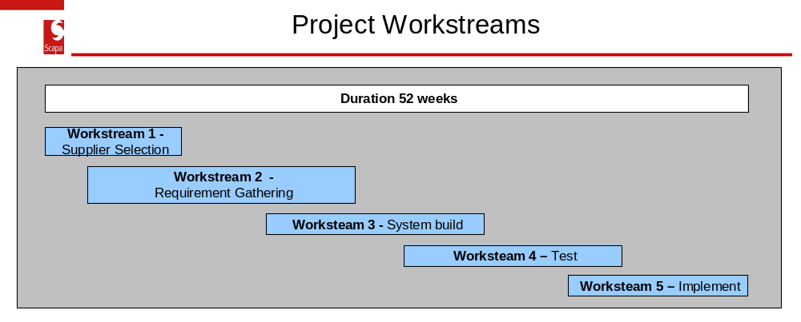

Milestone Planning
Milestone planning is a technique that can be used in conjunction with project planning. The idea is to set a number of key Milestones within a projects lifecycle, which collectively define a state of completeness for the project.
These Milestones then serve as a synchronization point and provide a good indicator for the overall state of health of a project.

Establishing Resource Needs
A well constructed and documented Project Plan is an excellent tool to determine total and individual resource needs. The tool can be used to communicate and agree resource commitment requirements with other areas of Scapa who are supporting the Project.

2.5 Completion of the Phase
The AE is responsible for ensuring that all tasks and activities within this section have been completed satisfactorily, before the project proceeds to the next Phase. This is a formal decision point.

3. Phase 3: Delivery
The control framework established during Phase 2, Initiation and Planning, must now be deployed across the Delivery Phase.

3.1 Controlling the Delivery Phase
The Project Manager should manage the project against the defined Project Plan.
The Project Manager should also concentrate effort on resource utilisation. Maximising the usage of available resources is key to the success of the phase.
The Project Manager’s responsibilities for controlling a stage can be summarised under the following headings:
- Providing direction to and utilisation of resources.
- Monitoring progress against plans.
- Updating plans where necessary.
- Tracking expenditure.
- Managing any deviations from plan.
- Managing/escalating the cost and impact of any change requests.
- Following agreed reporting procedures.
- Escalation to the AE if the Phase or individual Workstreams look likely to exceed tolerances on cost or time.
- Managing and updating the Risk and Response Plan.
- Managing and updating the Issue Log.
- Managing and updating the Lessons Learned Log.

3.2 Status Reporting, Review and Challenge
A fundamental element of Project Governance and Control arrangements is ensuring that the AE monitors the Delivery and subsequent phases within a formal framework.
Status reporting utilises output from the control processes established during the previous phase.
For more complex and material projects a Steering Committee should be formed. This should be chaired by the AE, and meet on a predefined basis, considering the necessity for at least a monthly meeting. Meetings should be informed by a formal progress report – see the Project Status Report template in the document library. This will cover the following areas:
- Progress in the Project Plan and Milestones.
- Financial Tracking
- Change control
- Key decision making
- Status of the Risk and Response Plan
- Status of the Project Issues Log
Actions points arising from the meetings should be formally taken and reviewed at subsequent meeting.
For smaller less complex projects the AE and the Project Manager should meet periodically to discuss and review the above areas.

3.3 Managing Workstream Interdependencies
Where Workstreams are employed, they will vary in duration throughout the Delivery phase of a project. Splitting a project into Workstreams provides a means of management and control. Workstream interdependencies must be accommodated on the Project Plan. These provide review and decision points for the AE and Project Manager to:
- Approve completion of the Workstream.
- Update project documentation (including Risk Log).
- Review the budget against revised forecast.
- Set tolerances on the next Phase or interdependent Workstream.
- Authorise commencement of the next Phase or Workstream.
In order to maintain the continuity of the project, review meetings are usually planned at key stages of each Workstream to assess progress and manage the impact on interdependent Worksteams.
By way of example, the diagram below shows a simple progression of Workstreams and where reviews might be scheduled.

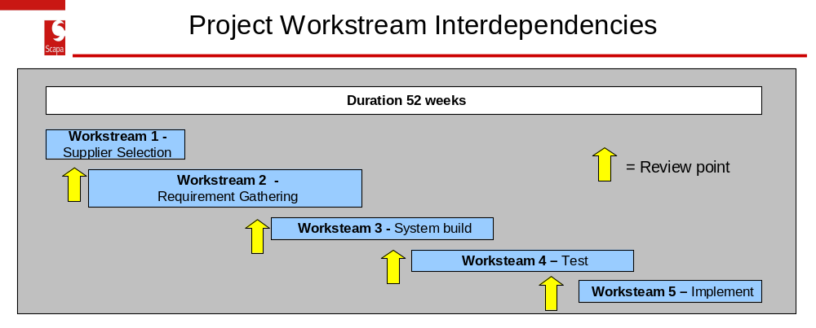

In summary, the main objectives in managing Workstream interdependencies are to ensure that:
- all products/outputs specific to that Workshop have been completed as defined,
- the AE has sufficient information to support a decision to be made on the continued viability of the project, and
- the Project Manager receives authority to begin the next Phase and or Workstream within agreed tolerances (usually time and cost).

3.4 Change Control
During the lifecycle of the project, changes will occur to the original plan and specification of products/deliverables. These can be major or minor deviations from the original scope of the project.
It is important to establish an approval process and to track these changes whether they require approval or not.
A project without a clear and well-defined change control process will inevitably experience difficulties both during the lifecycle of the project and with any subsequent audit process. It will be impossible to prove whether a change has been authorised at the correct level. The main cause of failure on a number of projects is lack of a sound change control process.
All changes should be requested, costed and recorded outside any parameters set by the Project Manager. By instigating this process, the Project Manager can assess the impact that changes will have on the project as a whole from a cost and time perspective. The change/s will provide valuable information at the Post-project Review Meeting when final outcomes are compared against the original Project Initiation Document.
The Project Manager should brief anyone who is involved in completing the Delivery Phase as part of the project on the Change Process. As a general rule all changes should be communicated for approval to the AE.
Any Change Request must include a detailed description of the proposed change and its impact on the project as a whole, or in respect to time, cost and quality. Some changes could have significant impact and may require AE referral and approval. The Project Manager and AE must set the level of authorisation required.
A central record of all change requests and approvals must be maintained by the Project Manager.
A template for a Change Request is available in the document library.

3.5 Replanning
The Project Manager must maintain up to date Project Plans throughout the project. These must be adjusted to reflect the following type of events:
- a slippage in part or all of the project,
- areas of the project that are ahead of schedule, where resource can be reallocated, and
- where there is a change in the scope of the project.
The impact on the projects ability to meet its key Milestones must be continually assessed.

3.6 Completion of the Phase
The AE is responsible for ensuring that all tasks and activities within this section have been completed satisfactorily, before the project proceeds to the next Phase. This is a formal decision point.

4. Closure & Post Review
At the conclusion of the project it is important to take stock of what has been achieved, the lessons to the learned and to celebrate success.

5.1 Post Project Lessons Learned Review
The Project Manager will schedule an internal Project Lessons Learned Review at the conclusion of the project.
The Lessons Learned Log should be made available to project staff and as a source of reference for anyone within Scapa.
Some of the basic questions to ask during the review are:
- Did we get what we said we wanted?
- Did we get what we actually needed?
- Can we see the difference between the two?
- Can we explain the difference between the two?
- Do we understand how this will influence our project management behaviour in the future?
Learn:
- What went well and what went badly?
Create a Legacy:
- Of knowledge, reference material and techniques to assist subsequent projects
- To influence the scope and approach of other, current projects, where necessary.
A template is available in the document library to help structure the review. A formal report should be produced and issued summarising the results of the exercise.
A major consideration during the closure of the project should be the communication of successes and recognition for those involved in the delivery.

5.2 Document Archiving and Lockdown
Section 2.3.7 refers the key documents associated with the project. At Closure arrangements should be made to archive and lockdown access to these, so that a full audit trail is available for subsequent review.

Jargon Buster
Like most jargon, it seems pointless until you start working with it, at which point it becomes a very useful way of describing the many people, situations and processes which almost every project will involve. This section of the handbook covers some of the commonly used jargon.

Accountable Executive (AE) - The person is a senior, responsible officer who owns the project. The term used to describe the senior person or the head of the project.
Baseline – The original officially sanctioned plan that can only be changed by the original approving body. Change control is mapped and tracked in a different version of the plan so that it is always possible to compare to initial plans and targets.
Bespoke - A product or an element of a product that is developed for a specific task and is not available ‘off the shelf’. Be aware that bespoke products, or elements of a product, are more expensive due to the development time/cost involved. This term is used extensively on IT projects.
Change Request Process - Once the project has a tightly defined scope, and the Project Manager has signed up to deliver that scope within a specific time and/or budget, the last thing they want is for the scope to change, either by adding new things or by redefining the requirements. A Change Request Process is a sensible, ordered approach to making sure that the project team are not culpable for overruns (time and cost) caused by this kind of change. The basic process goes like this:
- A change is requested, defining a variation to the original functional specification and setting out perceived benefits arising from that change.
- The team analyses the detailed changes and conducts an impact analysis, highlighting the expected changes in costs and risks.
- The Project Manager weighs the changes in costs/risks against the potential benefits and decides whether or not to accept the change. The Project Manager may escalate the change to the project AE for their decision.
- If the change is accepted, the project has a new scope, costs, timescales and risks, and the project team may no longer be expected to meet the old ones.
Communication Plan - The project is changing the world – fantastic! The project team must inform key stakeholders about it. Like all good things, this will take planning and effort.
Constraints - Senior managers can (and often do) ask for the moon on a stick. But it’s important that the Project Manager makes them aware of the limitations of time, budget, technical strategy and other aspects that will impinge on project delivery.
Deliverable/product (output) - The outcome from a specific task or piece of work is the output of what you're doing. It should be something obvious and tangible – on site this might be foundations or a site structure. For the Project Manager it might be the Project Plan.
Dependency - Something one task needs from another task before it can be started or completed.
Earned Value Management – A method of measuring performance on a project that assesses scope performance, schedule performance and cost performance separately and also their interactions with each other (e.g. ahead of schedule (good), but overspent financially (bad).
Key Performance Indicator (KPI) - A Key Performance Indicator is a measurement of how a supplier of a product or service is performing against any given or industry standard criteria. Benchmarking the criteria offers a way of improving performance.

Managing down risk - Once a risk has been recognised, categorised and costed, it is the responsibility of the owner of the risk to manage down its impact. The Risk and Response Plan will provide a means of recording efforts to manage down any risks.
Milestone - Milestone planning is an extremely useful planning method when you don’t have all the timescales required for the plan. It’s solely based on dependencies and allows you to set out a plan's skeleton.
Product Flow Diagram - A diagram that shows products for delivery produced in a logical sequence. Establishing this sequence will give a view of what products may be produced concurrently and what products have a dependency on other products. It is about getting everything in the right order.
Project Initiation Document (PID) - The Project Initiation Document is the terms of reference for the project and is frozen once signed. It contains the key parts of what, how, when and why the project will run. For capital projects, you won’t get the go-ahead or a budget without it. It is required to enable effective scrutiny on project organisation and delivery.
Project Lifecycle - All projects must have a beginning and end date. The Project Lifecycle encompasses all the time, tasks and activities between these two points including the Post-project Review. It does not include any ‘follow-on actions’ which may be recommended at the Post-project Review.
Reprofiling project expenditure - When there is forecast slippage on a project in any current year, the Project Manager must consider the impact on any subsequent years. This consideration must be before the next year’s budget is set (usually March/April). The Project Manager may submit a budget reprofile request through the departmental finance officer (usually no later than mid-January); this may involve reprofiling the slippage over a number of subsequent years in the Project Lifecycle. If this reprofiling exercise is not undertaken, the slippage rolls over into the following and subsequent years and is not managed in the best interest of the project or Scapa.
Resources - Everything needed to complete the project, but particularly people and funds.
Scope - What the project has agreed to deliver. Once signed off, defend it with your life.
Scope-creep - What happens when people have bright ideas for minor improvements? Great ideas they may be, but if they’re not in the agreed scope, Project Managers should not undertake the changes without a change request being accepted. Otherwise the work ends up being substantially more than agreed, yet budget and timescales haven’t changed.
Service Level Agreement (SLA) - A contractually enforceable agreement on the quality of service provided. The point of this is that you can make firm plans around whatever service level you've agreed, knowing that even if you don’t get that level of service, you’re going to get compensated (and perhaps more importantly, not blamed) for slippages.
Service offerings - The services offered by a department or an external supplier usually outlined as a bullet- pointed list with a very brief description.
Slippage - What you get when you start running over time or budget. Some slippage is unavoidable as in delay in the decision to spend by central government.
Stakeholder Management - Projects are made more difficult when stakeholders have different agendas, goals and priorities. As well as managing the project, a big part of a Project Manager’s role is keeping the stakeholders aligned with each other and with the project team. Include all stakeholders in your Communication Plan.
Stakeholders - Anyone who has a valid interest in your project. If your project affects someone else, they’re a ‘stakeholder’. Some stakeholders will have direct input into your project – some will even have sign-off – while others will simply have a representation of their interests.
War Room - A war room is a meeting room for the purpose of discussing project management.

